Jean-Louis George

26893546

GEOG 465 – Final Project

**Urban Growth in the Vancouver Metropolitan Area from 1991 to 2018**

**INTRO**

In this project I am seeking to find the amount of land use change, specifically urban growth, in the Vancouver metropolitan area between the years 1991 and 2018. I will be using data from the USGS portal for satellite imagery, namely an image from the Global Land Survey database (taken with the Landsat 5 sensors) for my 1991 reference, and an image from the Landsat 8 sensors for my 2018 reference. I will be manipulating and analysing these images in IDRISI’s Terrset program.

I grew up in South Delta which is located south of the larger urban centers, right near the Canadian/American border. This is an area with a lot of farmland, and it has indeed managed to keep a significant portion of this land from being paved over for new malls (although not all of it). As explained by Burchfield et al.: “Metro Vancouver had a head start on growth management relative to the Greater Toronto and Hamilton Area. Starting in the 1970s, British Columbia put in place strong protections for agricultural land with its Agricultural Land Reserve. But it is a consistent and long-standing approach to urban containment, to prevent growth from spilling into the countryside, that has produced results, including a reduction in the amount of land used for urban expansion and a greater diversity of housing stock. In recent years, Metro Vancouver has taken a more strategic approach to growth management, directing intensification to frequent transit corridors and urban centres.” (Burchfield, 8). From this kind of management we would hope to see only a modest increase in built-up area over the 27 years which I will look at in my study. Despite this, due to population growth during this time, I expect to see a growth of urban land use, and a decrease in farmland/vegetation, as well as forested areas. A distinction which is made in both Burchfield, and Darriau’s studies is the distinction between intensification – increasing the capacity of existing urban areas – and greenfield development – creating new urban areas from other land uses, also known as urban sprawl. I will not be taking into account any population data in my study, and will therefore be focusing on urban sprawl.

**METHODOLOGY**

The study area which I will be looking at is, as previously stated. The metropolitan area of Vancouver, as shown here in a natural composition:

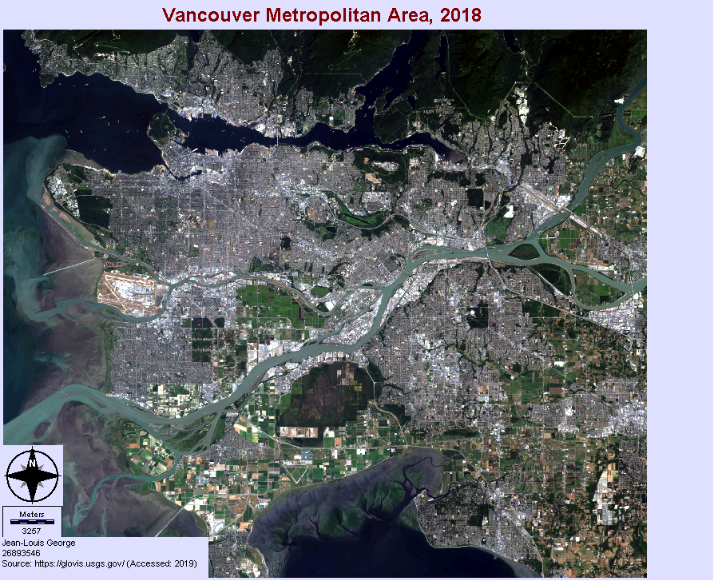

On the following page is a flowchart which depicts the steps I took in completing this project. I will now elaborate on certain decisions which were made in this process:

* Not all of the bands were used from either sensor. From the Landsat 5 sensor I used bands: 1, 2, 3, 4, 5, 7.From the Landsat 8 sensor I used the bands: 1, 2, 3, 4, 5, 6. The other bands which were available weren’t used because of several reasons including: they were thermal images, the radiometric correction did not turn out well.
* I initially clipped my raster images using a vector file of the Vancouver census area. This looked nice, however I quickly ran into several problems with this method. The main problem was that Terrset does not recognize No Data values, and therefore all of the excess area outside of the clipped image took on 0 values which interfered with further processes. Other problems included that the vector file clipped the ocean out, however it included rivers and lakes, and therefore it wouldn’t have removed the need to classify water. My solution to this problem was to clip the images using the WINDOW tool in Terrset. This method didn’t give me an exact, or official, area to work with, however for the limits of this project it worked well enough.
* I decided to settle on 4 categories for my classification, namely: water, farmland/vegetation, forest, and urban. I was initially going to focus on both urban growth, and farmland lost, however I came to realize that I would have also had to add another category for random vegetation, because there are obviously areas which are green, but are not farmland, but which surely have a similar spectral signature to farmland; such as fields, parks, etc… Because of this I decided to include vegetation with farmland, and focus on urban growth.
* I decided to use the Minimum Distance classification algorithm simply because it produced the most coherent maps by a long shot. I did go back and add and remove polygons from my training set, however I would have had to spend a LOT more time to satisfactorily differentiate the spectral signatures to a point where the other classification algorithms would have produced a satisfactory map.
* For my accuracy assessment, at the advice of Angela Kross, decided to have an order of magnitude more points per category than the total number of categories. In my case this resulted in a 40 points per category, for a total of 160 points.
* I had to calculate both the error of commission, and the error of omission in a separate spreadsheet. This was due to the fact that when converting from vector point data to raster, the background takes on a 0 value, which is then recognized in the ERRMAT tool as a value to include.
* For map #4 I reclassed the map in order to change the -1 value to a value of 2 in order to be able to have the 0 value be black.

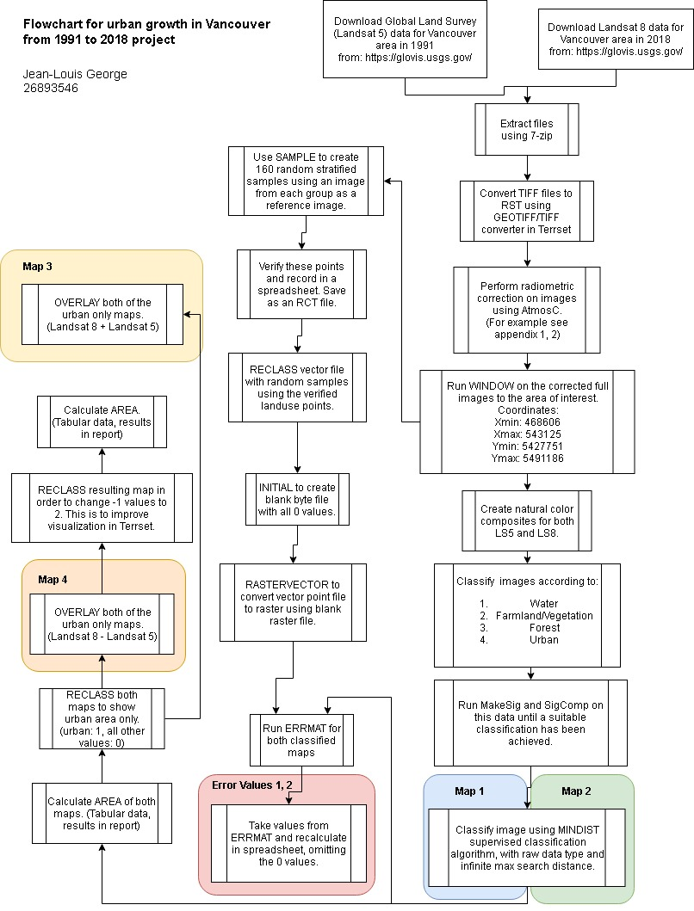

**RESULTS/DISCUSSION**

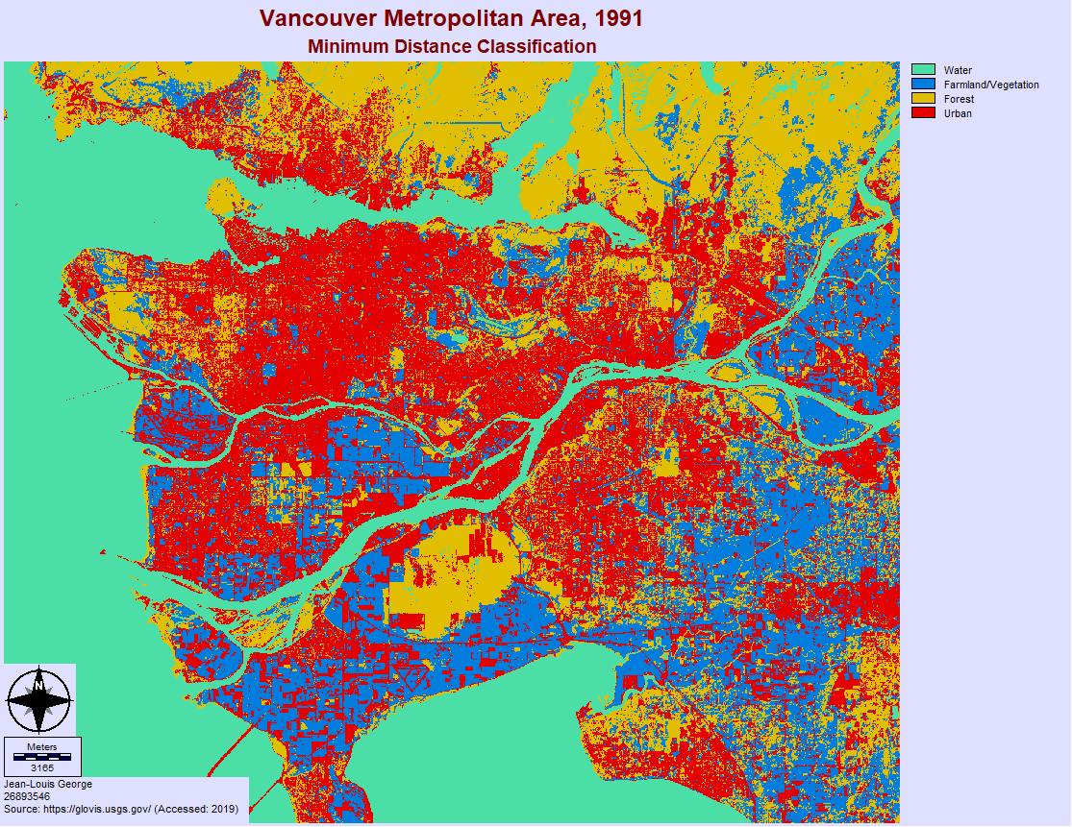Map #1

|  |  |  |  |  |  |  |  |
| --- | --- | --- | --- | --- | --- | --- | --- |
| **Error Matrix Analysis: Landsat 5 - 1991** | | | | |  |  |  |
|  | **1** | **2** | | **3** | **4** | **Total** | **ErrorC** |
| **1** | 41 | 0 | | 0 | 0 | **41** | **0.00000** |
| **2** | 1 | 21 | | 2 | 6 | **30** | **0.30000** |
| **3** | 1 | 9 | | 22 | 2 | **34** | **0.35294** |
| **4** | 2 | 5 | | 8 | 39 | **54** | **0.27778** |
| **Total** | **45** | **35** | | **32** | **47** | **159** |  |
| **Error0** | **0.08889** | **0.40000** | | **0.31250** | **0.17021** |  |  |
| **Overall accuracy (%)** | | |
| **77.36** | | |

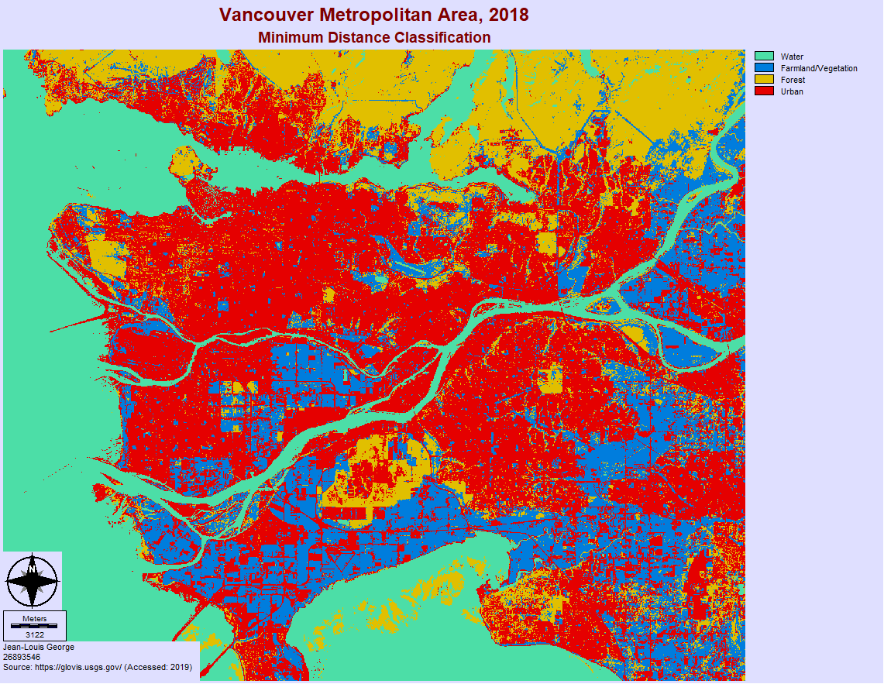Map #2

|  |  |  |  |  |  |  |  |
| --- | --- | --- | --- | --- | --- | --- | --- |
| **Error Matrix Analysis: Landsat 8 - 2018** | | | | |  |  |  |
|  | **1** | **2** | | **3** | **4** | **Total** | **ErrorC** |
| **1** | 41 | 0 | | 0 | 1 | **42** | **0.02381** |
| **2** | 1 | 14 | | 1 | 5 | **21** | **0.33333** |
| **3** | 1 | 9 | | 18 | 2 | **30** | **0.40000** |
| **4** | 0 | 7 | | 8 | 52 | **67** | **0.22388** |
| **Total** | 43 | 30 | | 27 | 60 | **160** |  |
| **Error0** | **0.04651** | **0.53333** | | **0.33333** | **0.13333** |  |  |
| **Overall Accuracy (%)** | | |
| **78.13** | | |

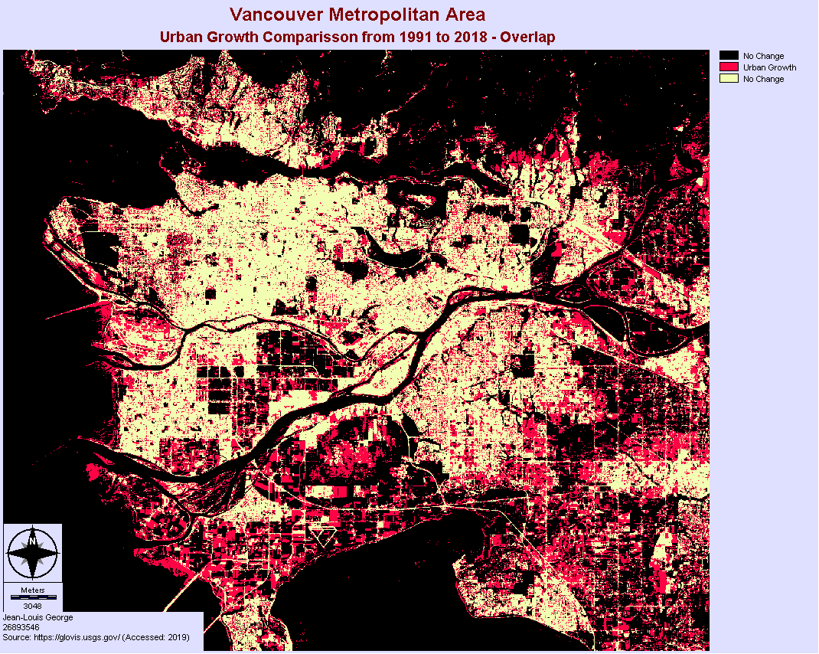Map #3

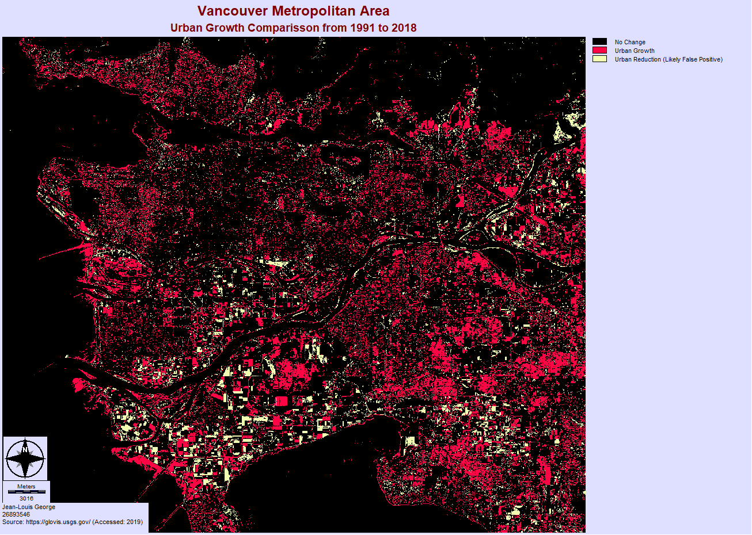Map #4

|  |  |
| --- | --- |
| Urban Growth |  |
| Category | Square Kilometer |
| Urban Growth | **251.0856** |
| Urban Reduction | 76.2381 |

Graph #1

As is shown in map #1, map #2, and perhaps more easily comparable in graph #1, the classification did indeed (thankfully) show the following:

* An increase in urban area.
* A decrease in both farmland/vegetation, and forested areas.
* Only small fluctuation in water area.

Overall these are indeed the trends which I hoped to achieve in this project. As is shown in the accuracy assessments under maps #1, and #2, I achieved an underwhelming 77.36 %, and 78.13 % for my overall accuracy respectively. Although these are sub-par results, and even in the context of assignment 2 would have had to been redone, I do not have the luxury of time and will have to be ok with these figures.

In maps #3, and #4, I isolate the urban growth category and compare the 1991, and 2018 results directly. As described in the methods, I do this first by adding the isolated maps to each other using OVERLAY. I realized, however, that this could be giving me some misleading information because there are areas which are categorized as urban in 1991, and then as something else in 2018. The result of this would make it seem as though there was more urban growth than is actually suggested by the data. This is because:

* 0 value represents no change.
* 1 value represents urban growth but could be achieved in two ways, one intended, the other unintended:
  + Intended: 2018 value = 1, 1991 value = 0.
  + Unintended: 2018 value = 0, 1991 value = 1.
* 2 value represents the urban areas which remained urban.

To work around this, the map #4 was created by subtracting the 1991 map from the 2018 map using OVERLAY. The values which were obtained from this were 1, 0, and -1, where:

* -1 represents urban reduction from a 2018 value = 0, 1991 value = 1.
* 0 value represents no change from either 0, or 1 values for both years.
* 1 represents urban growth from a 2018 value = 1, 1991 value = 0.

This difference represents one of two methods of obtaining the amount of urban growth:

1. By calculating the area of the urban growth category from map #4, from which we obtain a value of **251.0856 km2**. This method accounts for the difference between the two years.
2. By comparing the differences of total urban growth between the two years (obtained from graph #1’s data): 727.0812 – 552.2337 = **174.8475 km2**.

In what appears to be a graduate level project, Gabriel Townsend Darriau calculated that the built-up area in Vancouver increased from 798 km2 in 1991 to 992 km2 in 2011. This is a difference of 194 km2, which is relatively similar to my values. This makes me happy because it means that my results were not absurd. To be completely honest I am not sure why method #2 is less than method #1, I was expecting the opposite. One thing worth mentioning is that it is apparent that both the landsat 5 (1991), and landsat 8 (2018) map classifications had a hard time (although it is more evident in landsat 5) at differentiating between farmland, and urban areas. This is evident from the shape of some of the clusters of classified areas which are outside of the urban centers, and are clearly plots of farmland.

**CONCLUSION**

As was the common sense hypothesis in this case, according to this classification project, urban growth has indeed occurred over the past 30 odd years in Vancouver. Although my analysis confirmed this result, I do not have very much confidence in the accuracy and precision of the results. This is because the overall accuracy was too low (just below 80 % for both maps, and this was with an accuracy assessment which could have been significantly more rigorous), and I doubt that this would stand up to statistical scrutiny. As previously mentioned, there were certain problems which plagued the classification algorithms. The most common were: confusion between farmland and urban areas, as well as confusion between water and forested areas. Both of these errors occur due to the two opposite extremes in the spectral signatures; the farmland/urban confusion was due to similarly high reflectance, and the water/forest confusion was due to similarly low reflectance values.

In this project I chose to stick with supervised classification algorithms because of time constraints; after briefly attempting a few unsupervised algorithms, and investigating the spectral signatures of the images, it was apparent that quite a lot of time would be required to tweak the settings in order to obtain a satisfactory result. It would be a good idea to pursue unsupervised classification if there was more time available.

The best way to improve the results of this project would be to go back and continue refining the classification training set. As such, the main source of error was undoubtedly the human error involved in selecting the training sets. Another potential source of error was the human error involved in verifying the point data used in the accuracy assessment. The ideal method to reduce this error would be to either go out into the real world and verify the points, or at least verify them through up to date aerial photography (or some image with better resolution than that of the Landsat sensors).

**DATA SOURCE**

<https://glovis.usgs.gov/> (Accessed 2019)

**REFERENCES**

Darriau, G, T. (2017) *Measuring Urban Sprawl in Vancouver from 1971 to 2011.* Concordia Geography Labs.

Burchfield, M., & Kramer, A. (2015). *Growing Pains: Understanding the New Reality of Population and Dwelling Patterns in the Toronto and Vancouver Regions*. Neptis Foundation.